**DAILY ONLINE ACTIVITIES SUMMARY**

|  |  |  |  |  |  |  |  |  |
| --- | --- | --- | --- | --- | --- | --- | --- | --- |
| **Date:** | **02/06/2020** | | | | | **Name:** | **PRANEETA P HANDRAL** | |
| **Sem & Sec** | **4​th​ SEM. & ‘B’ SEC.** | | | | | **USN:** | **4AL19CS401** | |
| **Online Test Summary** | | | | | | | | |
| **Subject** | |  | | | | | | |
| **Max. Marks** | | **30** | | **Score** | | |  | |
| **Certification Course Summary** | | | | | | | | |
| **Course** | **PYTHON FOR MACHINE LEARNING** | | | | | | | |
| **Certificate Provider** | | | **Greatlearning academy** | | **Duration** | | | **5 Hrs.** |
| **Coding Challenges** | | | | | | | | |
| **Problem Statement:** **Write a Java program to find Perfect Sum Problem.**  Given an array arr[] of integers and an integer K, the task is to print all subsets of the given array with the sum equal to the given target K.  **Problem Statement:**  **Given an array of positive integers. Write a C Program to find inversion count of array.** | | | | | | | | |
| **Status:** **Executed.** | | | | | | | | |
| **Uploaded the report in Github** | | | | | **Yes** | | | |
| **If yes Repository name** | | | | | **LockdownCoding** | | | |
| **Uploaded the report in slack** | | | | | **Yes** | | | |

**Online Certification course Summary​: Today I have learn about some other Pandas - Saving and Loading data frames and also execute the some of the basic function programs .Finally today I have finished the certification course of the “Robotic Process Automation” Snapshot of the Certificates given below**

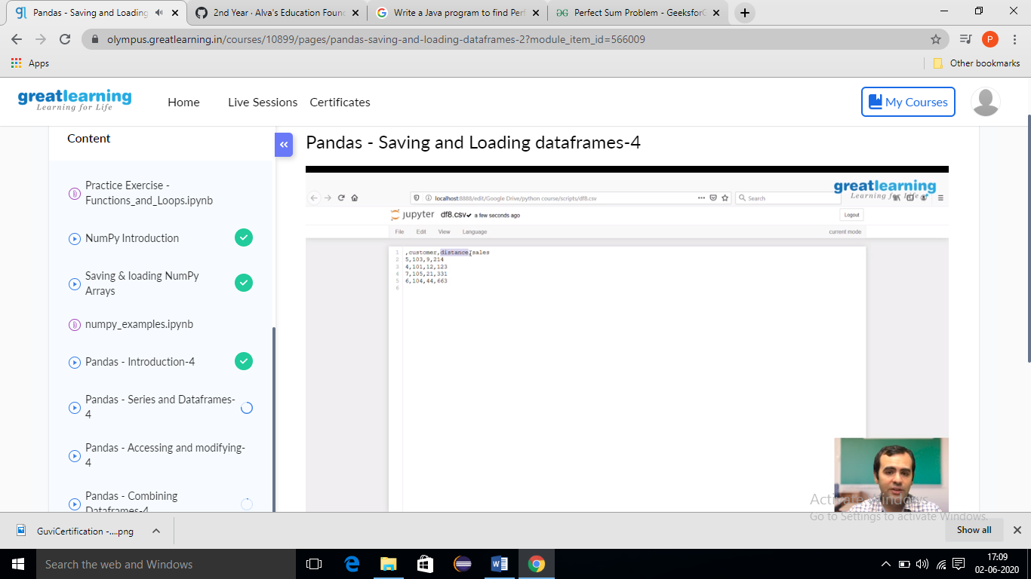

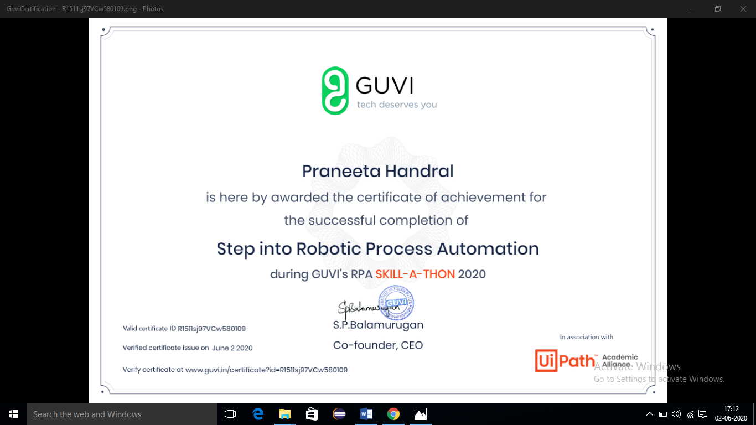

**Online Coding Summary​: Today I received two program one from Prof.Venkatesh CSE Dept another one from Prof. shilpa CSE Dept The program is mentioned above. to my GitHub repository and I’ve shared the snapshot below.**

